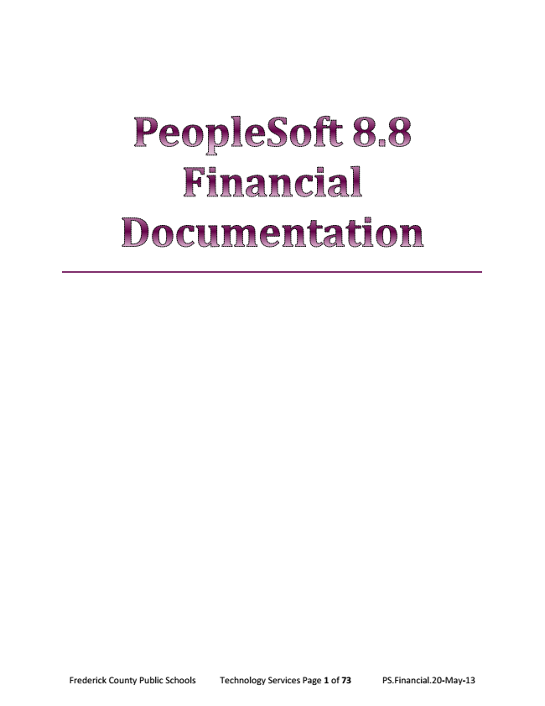

Frederick County Public Schools Technology Services Page 1 of 73 PS.Financial.20-May-13

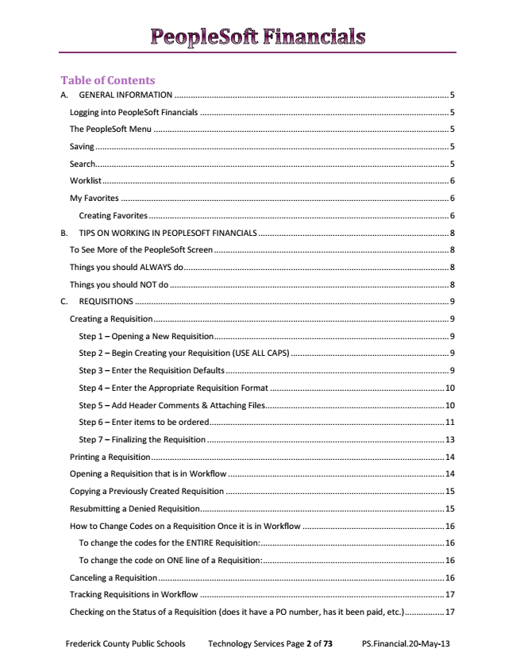

Table of Contents A. GENERAL INFORMATION ...................................................................................................................... 5
Logging into PeopleSoft Financials ........................................................................................................... 5
The PeopleSoft Menu ............................................................................................................................... 5
Saving ........................................................................................................................................................ 5
Search........................................................................................................................................................ 5
Worklist ..................................................................................................................................................... 6
My Favorites ............................................................................................................................................. 6
Creating Favorites ................................................................................................................................. 6
B. TIPS ON WORKING IN PEOPLESOFT FINANCIALS .................................................................................. 8
To See More of the PeopleSoft Screen ..................................................................................................... 8
Things you should ALWAYS do .................................................................................................................. 8
Things you should NOT do ........................................................................................................................ 8
C. REQUISITIONS ....................................................................................................................................... 9
Creating a Requisition ............................................................................................................................... 9
Step 1 – Opening a New Requisition ..................................................................................................... 9
Step 2 – Begin Creating your Requisition (USE ALL CAPS) .................................................................... 9
Step 3 – Enter the Requisition Defaults ................................................................................................ 9
Step 4 – Enter the Appropriate Requisition Format ........................................................................... 10
Step 5 – Add Header Comments & Attaching Files ............................................................................. 10
Step 6 – Enter items to be ordered ..................................................................................................... 11
Step 7 – Finalizing the Requisition ...................................................................................................... 13
Printing a Requisition .............................................................................................................................. 14
Opening a Requisition that is in Workflow ............................................................................................. 14
Copying a Previously Created Requisition .............................................................................................. 15
Resubmitting a Denied Requisition ......................................................................................................... 15
How to Change Codes on a Requisition Once it is in Workflow ............................................................. 16
To change the codes for the ENTIRE Requisition: ............................................................................... 16
To change the code on ONE line of a Requisition: .............................................................................. 16
Canceling a Requisition ........................................................................................................................... 16
Tracking Requisitions in Workflow ......................................................................................................... 17
Checking on the Status of a Requisition (does it have a PO number, has it been paid, etc.) ................. 17
Frederick County Public Schools Technology Services Page 2 of 73 PS.Financial.20-May-13

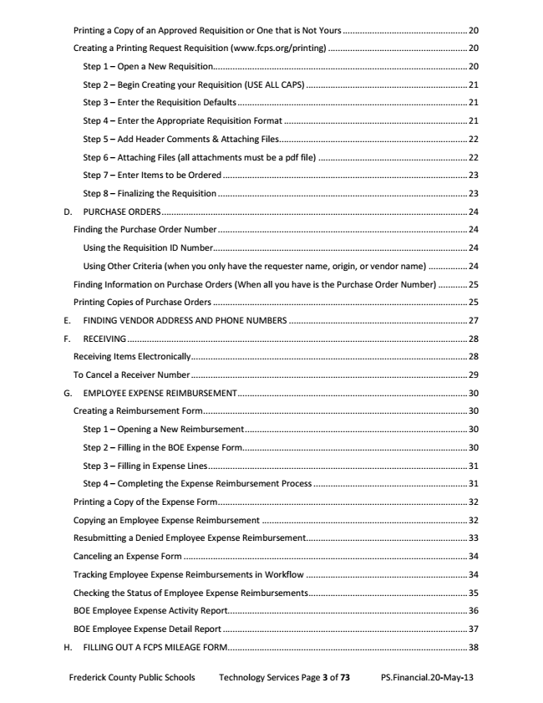

Printing a Copy of an Approved Requisition or One that is Not Yours ................................................... 20
Creating a Printing Request Requisition (www.fcps.org/printing) ......................................................... 20
Step 1 – Open a New Requisition........................................................................................................ 20
Step 2 – Begin Creating your Requisition (USE ALL CAPS) .................................................................. 21
Step 3 – Enter the Requisition Defaults .............................................................................................. 21
Step 4 – Enter the Appropriate Requisition Format ........................................................................... 21
Step 5 – Add Header Comments & Attaching Files ............................................................................. 22
Step 6 – Attaching Files (all attachments must be a pdf file) ............................................................. 22
Step 7 – Enter Items to be Ordered .................................................................................................... 23
Step 8 – Finalizing the Requisition ...................................................................................................... 23
D. PURCHASE ORDERS ............................................................................................................................. 24
Finding the Purchase Order Number ...................................................................................................... 24
Using the Requisition ID Number........................................................................................................ 24
Using Other Criteria (when you only have the requester name, origin, or vendor name) ................ 24
Finding Information on Purchase Orders (When all you have is the Purchase Order Number) ............ 25
Printing Copies of Purchase Orders ........................................................................................................ 25
E. FINDING VENDOR ADDRESS AND PHONE NUMBERS ......................................................................... 27
F. RECEIVING ........................................................................................................................................... 28
Receiving Items Electronically................................................................................................................. 28
To Cancel a Receiver Number ................................................................................................................. 29
G. EMPLOYEE EXPENSE REIMBURSEMENT .............................................................................................. 30
Creating a Reimbursement Form ............................................................................................................ 30
Step 1 – Opening a New Reimbursement ........................................................................................... 30
Step 2 – Filling in the BOE Expense Form............................................................................................ 30
Step 3 – Filling in Expense Lines .......................................................................................................... 31
Step 4 – Completing the Expense Reimbursement Process ............................................................... 31
Printing a Copy of the Expense Form ...................................................................................................... 32
Copying an Employee Expense Reimbursement .................................................................................... 32
Resubmitting a Denied Employee Expense Reimbursement .................................................................. 33
Canceling an Expense Form .................................................................................................................... 34
Tracking Employee Expense Reimbursements in Workflow .................................................................. 34
Checking the Status of Employee Expense Reimbursements ................................................................. 35
BOE Employee Expense Activity Report.................................................................................................. 36
BOE Employee Expense Detail Report .................................................................................................... 37
H. FILLING OUT A FCPS MILEAGE FORM .................................................................................................. 38
Frederick County Public Schools Technology Services Page 3 of 73 PS.Financial.20-May-13

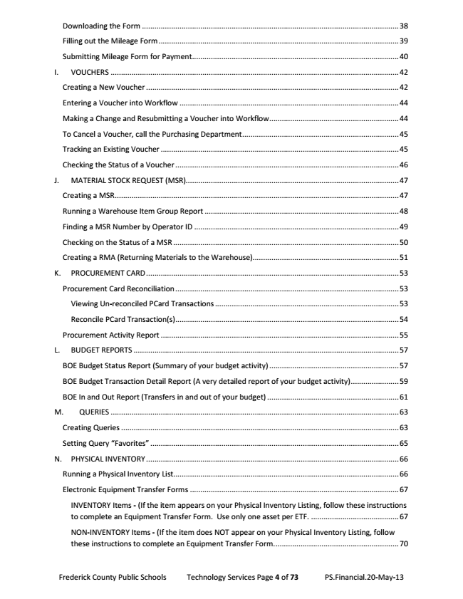

Downloading the Form ........................................................................................................................... 38
Filling out the Mileage Form ................................................................................................................... 39
Submitting Mileage Form for Payment ................................................................................................... 40
I. VOUCHERS .......................................................................................................................................... 42
Creating a New Voucher ......................................................................................................................... 42
Entering a Voucher into Workflow ......................................................................................................... 44
Making a Change and Resubmitting a Voucher into Workflow .............................................................. 44
To Cancel a Voucher, call the Purchasing Department ........................................................................... 45
Tracking an Existing Voucher .................................................................................................................. 45
Checking the Status of a Voucher ........................................................................................................... 46
J. MATERIAL STOCK REQUEST (MSR)...................................................................................................... 47
Creating a MSR ........................................................................................................................................ 47
Running a Warehouse Item Group Report ............................................................................................. 48
Finding a MSR Number by Operator ID .................................................................................................. 49
Checking on the Status of a MSR ............................................................................................................ 50
Creating a RMA (Returning Materials to the Warehouse)...................................................................... 51
K. PROCUREMENT CARD ......................................................................................................................... 53
Procurement Card Reconciliation ........................................................................................................... 53
Viewing Un-reconciled PCard Transactions ........................................................................................ 53
Reconcile PCard Transaction(s) ........................................................................................................... 54
Procurement Activity Report .................................................................................................................. 55
L. BUDGET REPORTS ............................................................................................................................... 57
BOE Budget Status Report (Summary of your budget activity) .............................................................. 57
BOE Budget Transaction Detail Report (A very detailed report of your budget activity) ....................... 59
BOE In and Out Report (Transfers in and out of your budget) ............................................................... 61
M. QUERIES .......................................................................................................................................... 63
Creating Queries ..................................................................................................................................... 63
Setting Query “Favorites” ....................................................................................................................... 65
N. PHYSICAL INVENTORY ......................................................................................................................... 66
Running a Physical Inventory List ............................................................................................................ 66
Electronic Equipment Transfer Forms .................................................................................................... 67
INVENTORY Items - (If the item appears on your Physical Inventory Listing, follow these instructions to complete an Equipment Transfer Form. Use only one asset per ETF. .......................................... 67
NON-INVENTORY Items - (If the item does NOT appear on your Physical Inventory Listing, follow these instructions to complete an Equipment Transfer Form. ........................................................... 70
Frederick County Public Schools Technology Services Page 4 of 73 PS.Financial.20-May-13

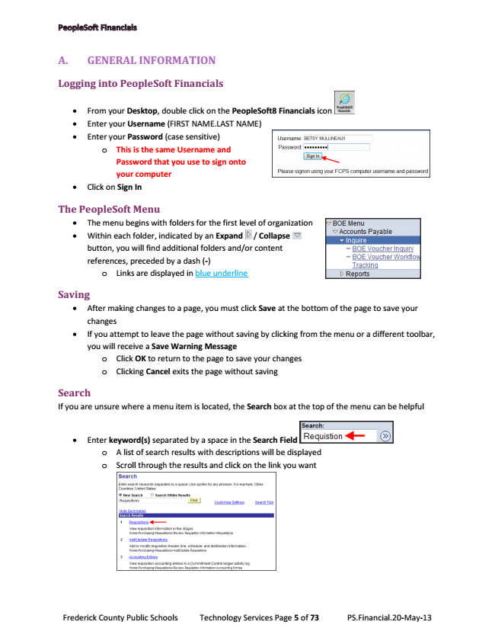

A. GENERAL INFORMATION
Logging into PeopleSoft Financials
• From your Desktop, double click on the PeopleSoft8 Financials icon
• Enter your Username (FIRST NAME.LAST NAME)
• Enter your Password (case sensitive)
o This is the same Username and
Password that you use to sign onto your computer
• Click on Sign In
The PeopleSoft Menu
• The menu begins with folders for the first level of organization
• Within each folder, indicated by an Expand / Collapse button, you will find additional folders and/or content references, preceded by a dash (-)
o Links are displayed in blue underline
Saving
• After making changes to a page, you must click Save at the bottom of the page to save your changes
• If you attempt to leave the page without saving by clicking from the menu or a different toolbar, you will receive a Save Warning Message
o Click OK to return to the page to save your changes o Clicking Cancel exits the page without saving
Search If you are unsure where a menu item is located, the Search box at the top of the menu can be helpful
• Enter keyword(s) separated by a space in the Search Field
o A list of search results with descriptions will be displayed o Scroll through the results and click on the link you want
Frederick County Public Schools Technology Services Page 5 of 73 PS.Financial.20-May-13

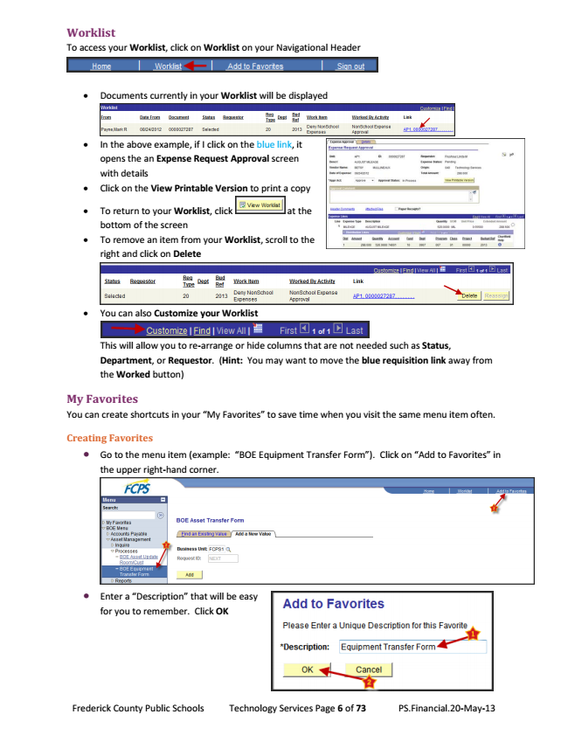

Worklist To access your Worklist, click on Worklist on your Navigational Header
• Documents currently in your Worklist will be displayed
• In the above example, if I click on the blue link, it opens the an Expense Request Approval screen with details
• Click on the View Printable Version to print a copy
• To return to your Worklist, click at the bottom of the screen
• To remove an item from your Worklist, scroll to the right and click on Delete
• You can also Customize your Worklist
This will allow you to re-arrange or hide columns that are not needed such as Status, Department, or Requestor. (Hint: You may want to move the blue requisition link away from the Worked button)
My Favorites You can create shortcuts in your “My Favorites” to save time when you visit the same menu item often.
Creating Favorites
•
Go to the menu item (example: “BOE Equipment Transfer Form”). Click on “Add to Favorites” in the upper right-hand corner.
•
Enter a “Description” that will be easy for you to remember. Click OK
Frederick County Public Schools Technology Services Page 6 of 73 PS.Financial.20-May-13

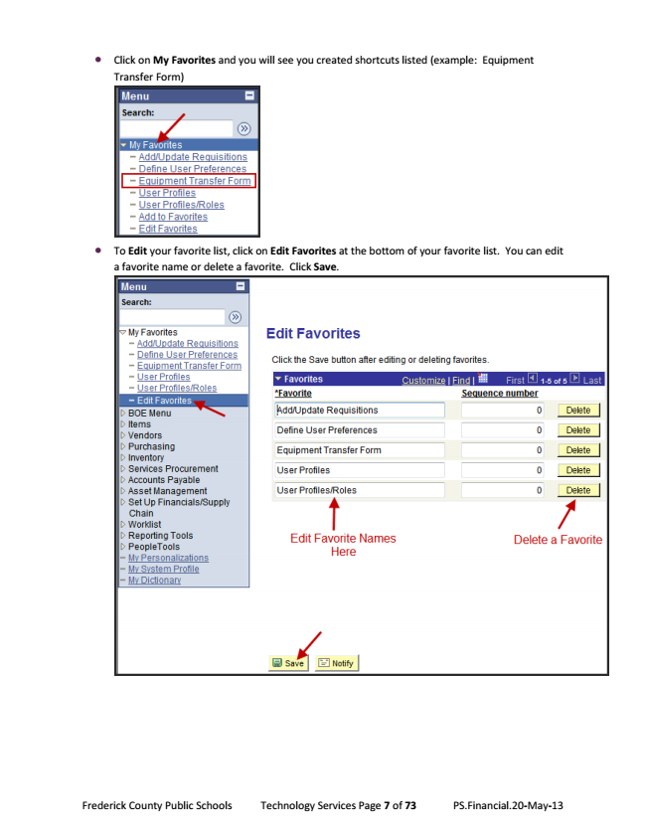

•
Click on My Favorites and you will see you created shortcuts listed (example: Equipment Transfer Form)
•
To Edit your favorite list, click on Edit Favorites at the bottom of your favorite list. You can edit a favorite name or delete a favorite. Click Save.
Frederick County Public Schools Technology Services Page 7 of 73 PS.Financial.20-May-13

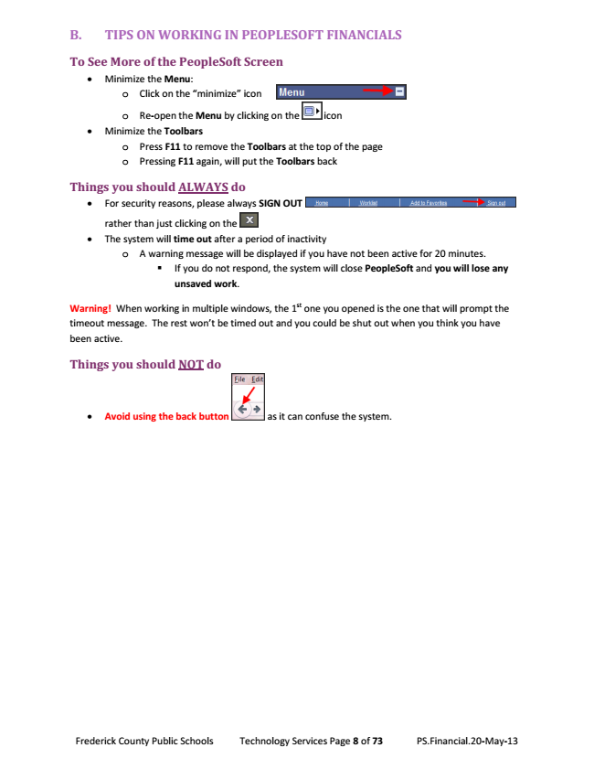

B. TIPS ON WORKING IN PEOPLESOFT FINANCIALS
To See More of the PeopleSoft Screen
• Minimize the Menu:
o Click on the “minimize” icon
o Re-open the Menu by clicking on the icon
• Minimize the Toolbars
o Press F11 to remove the Toolbars at the top of the page o Pressing F11 again, will put the Toolbars back
Things you should ALWAYS do
• For security reasons, please always SIGN OUT
rather than just clicking on the
• The system will time out after a period of inactivity
o A warning message will be displayed if you have not been active for 20 minutes.
▪ If you do not respond, the system will close PeopleSoft and you will lose any unsaved work.
Warning! When working in multiple windows, the 1st one you opened is the one that will prompt the timeout message. The rest won’t be timed out and you could be shut out when you think you have been active.
Things you should NOT do
• Avoid using the back button as it can confuse the system.
Frederick County Public Schools Technology Services Page 8 of 73 PS.Financial.20-May-13

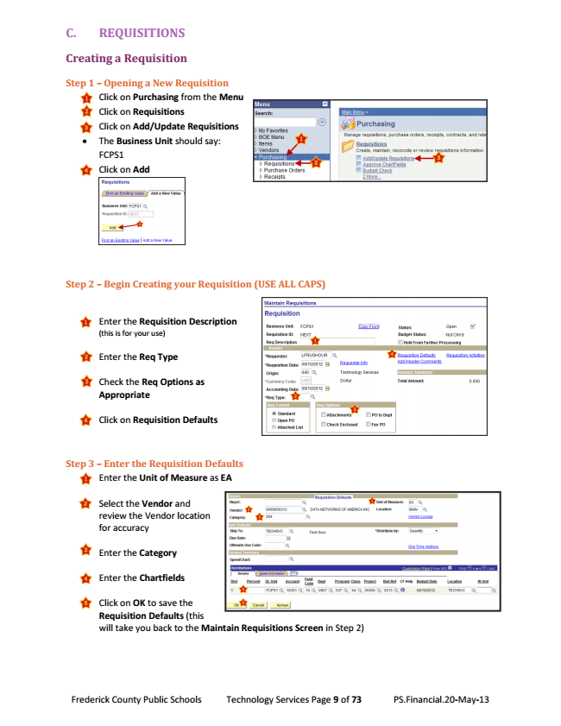

C. REQUISITIONS
Creating a Requisition
Step 1 – Opening a New Requisition
• Click on Purchasing from the Menu
• Click on Requisitions
• Click on Add/Update Requisitions
• The Business Unit should say: FCPS1
• Click on Add
Step 2 – Begin Creating your Requisition (USE ALL CAPS)
• Enter the Requisition Description (this is for your use)
• Enter the Req Type
• Check the Req Options as Appropriate
• Click on Requisition Defaults
Step 3 – Enter the Requisition Defaults
• Enter the Unit of Measure as EA
• Select the Vendor and review the Vendor location for accuracy
• Enter the Category
• Enter the Chartfields
• Click on OK to save the Requisition Defaults (this will take you back to the Maintain Requisitions Screen in Step 2)
Frederick County Public Schools Technology Services Page 9 of 73 PS.Financial.20-May-13

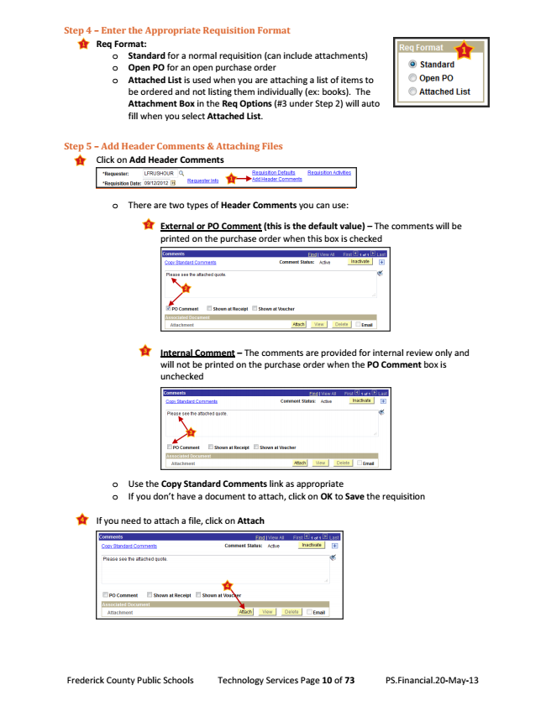

Step 4 – Enter the Appropriate Requisition Format
• Req Format:
o Standard for a normal requisition (can include attachments) o Open PO for an open purchase order o Attached List is used when you are attaching a list of items to
be ordered and not listing them individually (ex: books). The Attachment Box in the Req Options (#3 under Step 2) will auto fill when you select Attached List.
Step 5 – Add Header Comments & Attaching Files
• Click on Add Header Comments
o There are two types of Header Comments you can use:
▪ External or PO Comment (this is the default value) – The comments will be printed on the purchase order when this box is checked
▪ Internal Comment – The comments are provided for internal review only and will not be printed on the purchase order when the PO Comment box is unchecked
o Use the Copy Standard Comments link as appropriate o If you don’t have a document to attach, click on OK to Save the requisition
• If you need to attach a file, click on Attach
Frederick County Public Schools Technology Services Page 10 of 73 PS.Financial.20-May-13

