Charging for Lost Items

Here are the procedures we are to following in charging for lost items.

Tyler Condren checked out the book Improving schools for African American Students (30003000416436). He unfortunately lost the book. To charge him for replacement of the item perform the following operations:

Call up his borrower record. Go to the checkout screen. Highlight the item that is reported lost. At the bottom of the screen click on the Marked Selected pull down and select Lost.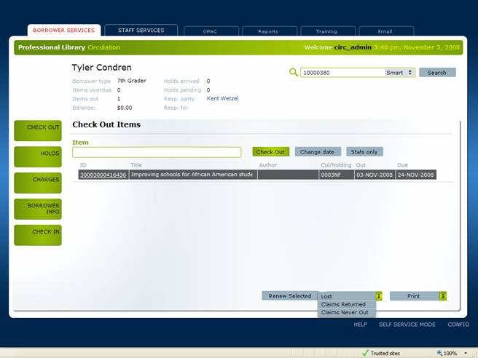

A popup will appear with the cost of the item. You can accept this cost or put in a different value. You also have an option of entering a comment.

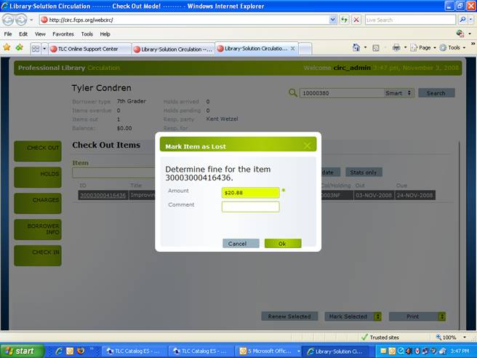

The item and the fine will be linked in the borrower under Charges.
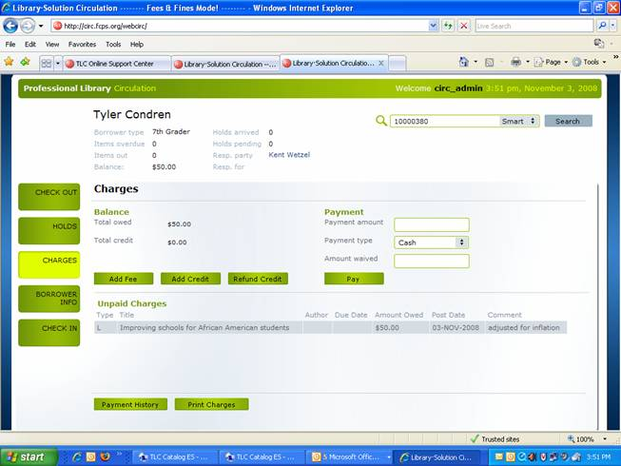

The item status is automatically changed to Lost. If by chance the item is found and it is checked-in the outstanding charges can be waived.

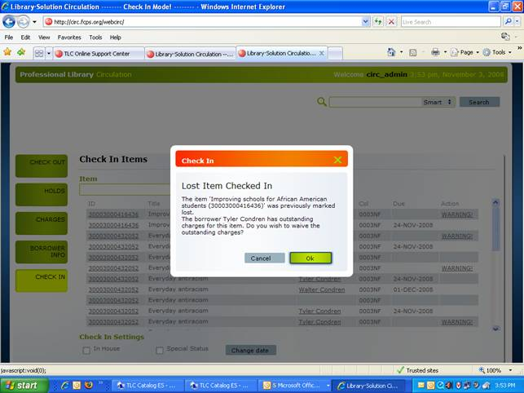
Clicking OK clears a student’s record.

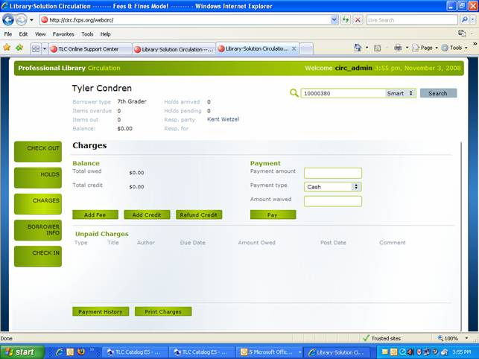

In the future you should be able to perform this functionality in Checkin using the Special Status, but for now it needs to be done on the checkout screen.

If the item is not returned and payment is to be made just on to the borrower record click on Charges and enter the amount paid and/or waived and click on the Pay button.

